
The Annual General Meeting of Satterthwaite Parish Council to be held in the Parish Room, Satterthwaite on Monday 8th June 2026 at 7.15 pm for the purpose of transacting the business outlined in the agenda below.
Agenda - AGM
Item |  | Additional  information
Elections
1 | Election of the Chairman
2 | Election of the Deputy Chair
Opening Administration

3 | Welcome and Introductions  Apologies  Emma Nield
4 | Declarations of interest  - To receive declarations by elected and co-opted members of disclosable pecuniary interests in respect of items on this agenda
5 | Requests for Dispensations  - The clerk to report any requests received since the previous meeting for dispensations to speak and/or vote on any matter where a member has a disclosable pecuniary interest.
6 | Minutes  - To authorise the Chair to review and sign the last AGM minutes from 30th June 2025 | Minutes attached
Matters for consideration
7 | Public participation  - To receive comments and representations from members of the public in relation to any item on the agenda
8 | Review of Policies  - Standing Orders  - Financial Regulations  - Reserves  - Transparency  - IT policy  - Personal data protection policy  - Grievance  - Dealing with media/press  - Code of conduct  To be agreed and signed off for 2026/2027 | On website
9 | Review of assets – asset register | Attached
10 | Review of insurance – Zurich
Finance
11 | Year-end accounts  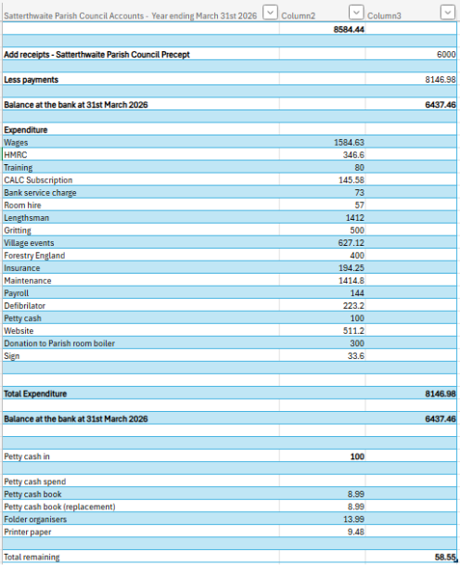
12 | Signatories for banking system – to review
13 | Unity bank - to approve continuation
14 | AGM date – mandated for May 2027
Close

